**UNIT-2**

**1. Hybrid electric drive Train:** Basic concept of hybrid traction, Introduction to various hybrid drive train topology/configurations, power flow control in hybrid drive train topology, fuel efficiency analysis

**2. Electric Drive trains**: Basic concept of Electric traction, Introduction to various Electric Drive Train topology, power flow control in Electric drive train topology, fuel efficiency analysis

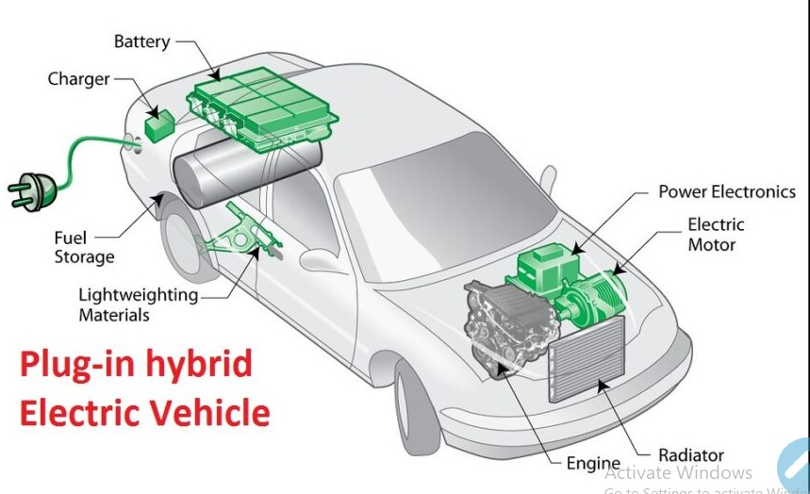

Prepared by: Dr.S.Suresh Reddy

Professor & HOD Dept. of EEE

&

K.V.Thulasi Ram

Asst. Prof Dept. of EEE

**Part 2: Electric Drive trains**

**Configurations/Topology of EVs**

Previously, the EV was mainly converted from the existing ICEV by replacing the IC engine and fuel tank with an electric motor drive and battery pack while retaining all the other components, as shown in Figure 4.1. Drawbacks such a sits heavy weight, lower flexibility, and performance degradation have caused the use of this type of EV to fade out. In its place, the modern EV is purposely built, based on original body and frame designs. This satisfies the structure requirements unique to EVs and makes use of the greater flexibility of electric propulsion.

A modern electric drive train is conceptually illustrated in Figure 4.2 The drive train consists of three major subsystems: electric motor propulsion, energy source, and auxiliary. The electric propulsion subsystem is comprised of the vehicle controller, the power electronic converter, the electric motor, mechanical transmission, and driving wheels. The energy source subsystem involves the energy source, the energy management unit, and the energy refueling unit. The auxiliary subsystem consists of the power steering unit, the hotel climate control unit, and the auxiliary supply unit.

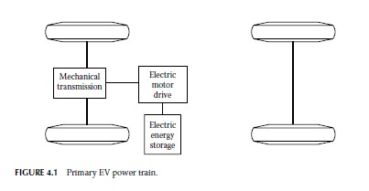

Based on the control inputs from the accelerator and brake pedals, the vehicle controller provides proper control signals to the electronic power converter, which functions to regulate the power flow between the electric motor and energy source.

The backward power flow is due to the regenerative braking of the EV and this regenerated energy can be restored into the energy source, provided the energy source is receptive. Most EV batteries as well as ultra-capacitors and flywheels readily possess the ability to accept regenerative energy. The energy management unit cooperates with the vehicle controller to control the regenerative braking and its energy recovery. It also works with the energy refueling unit to control the refueling unit and to monitor the usability of the energy source.

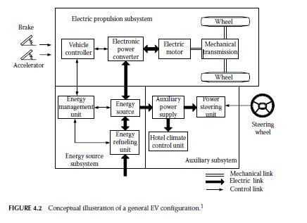

The auxiliary power supply provides the necessary power with different voltage levels for all the EV auxiliaries, especially the hotel climate control and power steering units.

There are a variety of possible EV configurations due to the variations in electric propulsion characteristics and energy sources, as shown in Figure 4.3.

a) Figure 4.3a shows the configuration of the first alternative, in which an electric propulsion replaces the IC engine of a conventional vehicle drive train. It consists of an electric motor, a clutch, a gearbox, and a differential. The clutch and gearbox may be replaced by an automatic transmission.

The clutch is used to connect or disconnect the power of the electric motor from the driven wheels. The gearbox provides a set of gear ratios to modify the speed–power (torque) profile to match the load requirement The differential is a mechanical device (usually a set of planetary gears), which enables the wheels of both sides to be driven at different speeds when the vehicle runs along a curved path

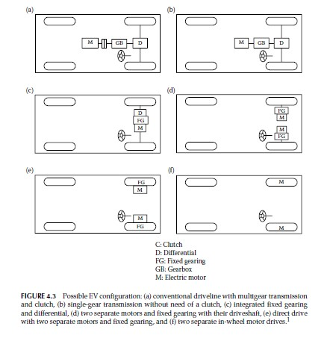

FIGURE 4.3 Possible EV configuration:

(a) Conventional driveline with multigear transmission and clutch

(b) single-gear transmission without need of a clutch

(c) Integrated fixed gearing and differential

(d) Two separate motors and fixed gearing with their driveshaft

(e) Direct drive with two separate motors and fixed gearing

(f) Two separate in-wheel motor drives.

.

b. With an electric motor that has a constant power in a long speed range a fixed gearing can replace the multispeed gearbox and reduce the need for a clutch. This configuration not only reduces the size and weight of the mechanical transmission, it also simplifies the drive train control because gear shifting is not needed.

c. Similar to the drive train in (b), the electric motor, the fixed gearing, and the differential can be further integrated into a single assembly while both axles point at both driving wheels. The whole drive train is further simplified and compacted.

d. In Figure 4.3d, the mechanical differential is replaced by using two traction motors. Each of them drives one side wheel and operates at a different speed when the vehicle is running along a curved path.

e. In order to further simplify the drive train, the traction motor can be placed inside a wheel. This arrangement is the so-called in-wheel drive. A thin planetary gear set may be employed to reduce the motor speed and enhance the motor torque. The thin planetary gear set offers the advantage of a high-speed reduction ratio as well as an inline arrangement of the input and output shaft.

f. By fully abandoning any mechanical gearing between the electric motor and the driving wheel, the out-rotor of a low-speed electric motor in the in-wheel drive can be directly connected to the driving wheel. The speed control of the electric motor is equivalent to the control of the wheel speed and hence the vehicle speed. However, this arrangement requires the electric motor to have a highr torque to start and accelerate the vehicle.

**2. 1 Performance of EVs**

A vehicle’s driving performance is usually evaluated by its acceleration time, maximum speed, and gradeability. In EV drive train design, proper motor power rating and transmission parameters are the primary considerations to meet the performance specification.

The design of all these parameters depends mostly on the speed–power (torque) characteristics of the traction motor, and will be discussed in this chapter

**2..1.1 Traction Motor Characteristics**

Variable-speed electric motor drives usually have the characteristics shown in Figure 4.4. At the low-speed region (less than the base speed as marked in Figure 4.4), the motor has a constant torque.

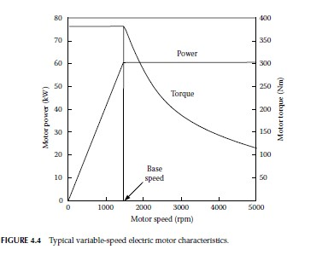

In the high-speed region ( higher than the base speed), the motor has a constant power. This characteristic is usually represented by a speed ratio x, defined as the ratio of its maximum speed to its base speed. In low-speed operation, voltage supply to the motor increases with the increase of speed through the electronic converter while the flux is kept constant.

At the point of base speed, the voltage of the motor reaches the source voltage. After the base speed, the motor voltage is kept constant and the flux is weakened, dropping hyperbolically with increasing speed. Hence, its torque also drops hyperbolically with increasing speed.

Figure 4.5 shows the torque–speed profiles of a 60 kW motor with different speed ratios x (x = 2, 4, and 6). It is clear that with a long constant power region, the maximum torque of the motor can be significantly increased, and hence vehicle acceleration and gradeability performance can be improved and the transmission can be simplified.

However, each type of motor inherently has its limited maximum speed ratio. For example, a permanent magnet motor has a small x (<2) because of the difficulty of field weakening due to the presence of the permanent magnet. Switched reluctance motors may achieve x > 6 and induction motors about x = 4.2,5

**2.2 Energy Consumption / fuel efficiency analysis**

In transportation, the unit of energy is usually kilowatt-hour (kWh) rather than joule or kilojoule ( J or kJ). The energy consumption per unit distance in kWh/km is generally used to evaluate the vehicle energy consumption. However, for ICEVs the commonly used unit is a physical unit of fuel volume per unit distance, such as liters per 100 km (L/100 km). In the United States, the distance per unit volume of fuel is usually used; this is expressed as miles per gallon (mpg).

On the other hand, for battery-powered EVs, the original energy consumption unit in kWh, measured at the battery terminals, is more suitable. The battery energy capacity is usually measured in kWh and the driving range per battery charge can be easily calculated. Similar to ICEVs, L/100 km (for liquid fuels) or kg/100 km (for gas fuels such as hydrogen) or mpg or miles per kilogram is a more suitable unit of measurement for vehicles that use gaseous fuels.

Energy consumption is an integration of the power output at the battery terminals. For propelling, the battery power output is equal to the resistance power and power losses in the transmission and motor drive, including power losses in the electronics. The power losses in transmission and motor drive are represented by their efficiencies ηt and ηm, respectively. Thus, the battery power output can be expressed as

F:\dept works\HEV\ehv latest notes screen shots\Screenshot 2022-09-05 113809.jpg

Here, the non-traction load (auxiliary load) is not included. In some cases, the auxiliary loads may be too significant to be ignored and should be added to the traction load. When regenerative braking is effective on an EV, a part of the braking energy wasted in conventional vehicles can be recovered by operating the motor drive as a generator and restoring it into the batteries. The regenerative braking power at the battery terminals can also be expressed as

F:\dept works\HEV\ehv latest notes screen shots\Screenshot 2022-09-05 113906.jpg

where road grade i or acceleration dV/dt or both are negative, and α (0 < α < 1) is the percentage of the total braking energy that can be regenerated

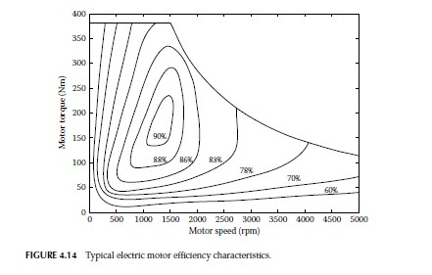

by the electric motor, called the regenerative braking factor. The regenerative braking factor α is a function of the applied braking strength and the design and control of the braking system, which will be discussed in detail in the later chapters. The net energy consumption from the batteries is

F:\dept works\HEV\ehv latest notes screen shots\Screenshot 2022-09-05 114111.jpg

It should be noted that the braking power in Equation 4.17 has a negative sign. When the net battery energy consumption reaches the total energy in the batteries, measured at their terminal, the batteries are empty and need to be charged. The traveling distance between two charges (usually called effective travel range) is determined by the total energy carried by the batteries, the resistance power, and the effectiveness of the regenerative braking (α).

The efficiency of a traction motor varies with its operating points on the speed–torque (speed–power) plane as shown in Figure 4.14, where the most efficient operating area exists. In power train design, this area should overlap or at least be as close as possible to the area of the greatest operation as mentioned in the previous section.

**2.1.2Energy Efficiency of ICEV and Electric Vehicles**

❖ Let us see the powertrain efficiency of individual IC engine based vehicle and electric vehicle. So in a IC engine based vehicle, if we assume a energy input of 100%, the major loss happens as heat energy.

❖ So 62% of the energy input to a IC engine is wasted as heat energy. Secondly, a good amount of loss which is 17% happens when the IC engine is left idling. So this is required because a IC engine is not able to start and stop at very frequent times so that the efficiency is best.

Figure 3.7: Energy efficiency analysis of ICEV and EV

**Efficiency comparison of different power trains**

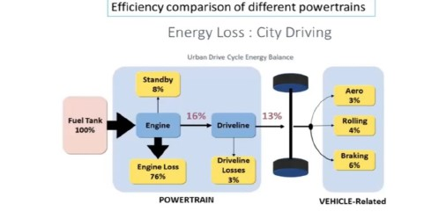

Figure 3.8: Energy efficiency analysis of ICEV at city driving Conditions

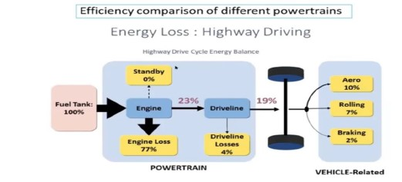

Figure 3.9: Energy efficiency analysis of ICEV at Urban driving Conditions

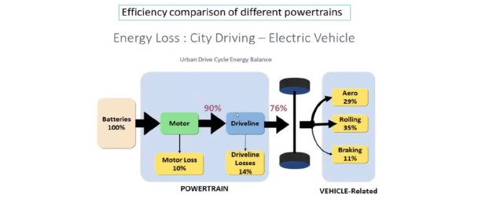

Figure 3.10: Energy efficiency analysis of Electric Vehicle at Urban driving Conditions

❖ So we have a mechanical losses which are known as driveline losses of 6% in a IC engine based vehicle. So in totality we can see that the effective energy which is available in the shaft is only 15%.

❖ If we see the similar thing in a EV powertrain and if we start with energy input of 100%, a EV powertrain generally faces a electrical loss of around 14%, and a driveway line losses which is 6%.

❖ So it can be even lesser, if we use a you know very high performance EV which doesn’t have gears or which doesn’t have a differential, so it can be even lesser. So typically we get the effective energy utilization of 80% which is very high compared to a IC engine based vehicle.

**Part 1: Concept of Hybrid Electric Drive Trains**

Basically, any vehicle power train is required to

(1) Develop sufficient power to meet the demands of vehicle performance,

(2) carry sufficient energy onboard to support the vehicle driving a sufficient range,

(3) Demonstrate high efficiency

(4) emit few environmental pollutants.

Broadly, a vehicle may have more than one power train. Here, the power train is defined as the combination of the energy source and the energy converter or power source, such as the gasoline (or diesel)–heat engine system, the hydrogen–fuel cell– electric motor system, the chemical battery–electric motor system, and so on.

A vehicle that has two or more power trains is called a hybrid vehicle. A hybrid vehicle with an electrical power train is called an HEV. The drive train of a vehicle is defined as the aggregation of all the power trains.

A hybrid vehicle drive train usually consists of no more than two power trains. More than two power trains will make the drive train very complicated. For the purpose of recapturing braking energy that is dissipated in the form of heat in conventional IC engine vehicles, a hybrid drive train usually has a power train that allows energy to flow bidirectionally.

The other one is either bidirectional or unidirectional. Figure 5.1 shows the concept of a hybrid drive train and the possible different power flow routes. A hybrid drive train can supply its power to the load by a selective power train. There are many available patterns of operating two power trains to meet the load requirement:

1. Power train 1 alone delivers its power to the load.

2. Power train 2 alone delivers its power to the load.

3. Both power train 1 and power train 2 deliver their power to the load simultaneously.

4. Power train 2 obtains power from the load (regenerative braking).

5. Power train 2 obtains power from power train 1.

6. Power train 2 obtains power from power train 1 and the load simultaneously.

7. Power train 1 delivers power to the load and to power train 2simultaneously.

8. Power train 1 delivers its power to power train 2, and power train 2 delivers its power to the load.

9. Power train 1 delivers its power to the load, and the load delivers the power to power train 2.

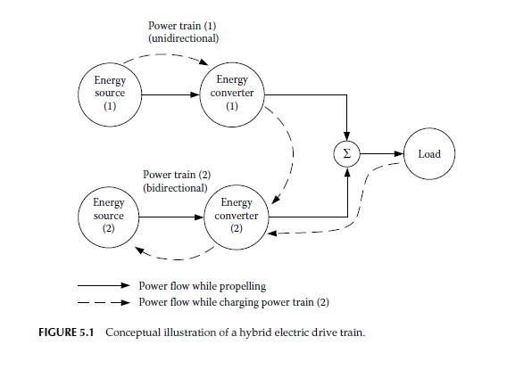

In the case of hybridization with a gasoline (diesel)–IC engine (power train 1) and a battery–electric machine (power train 2), pattern (1) is the engine alone propelling mode.

This may be used when the batteries are almost completely depleted and the engine has no remaining power to charge the batteries, or when the batteries have been fully charged and the engine is able to supply sufficient power to meet the power demands of the vehicle.

Pattern (2) is the pure electric propelling mode, in which the engine is shut off. This pattern may be used for situations where the engine cannot operate effectively, such as very low speed, or in areas where emissions are strictly prohibited.

Pattern (3) is the hybrid traction mode and may be used when large power is needed, such as during sharp accelerating or steep hill climbing.

Pattern (4) is the regenerative braking mode, by which the kinetic or potential energy of the vehicle is recovered through the electric motor functioning as a generator. The recovered energy is then stored in the batteries and reused later on.

Pattern (5) is the mode in which the engine charges the batteries while the vehicle is at a standstill, coasting, or descending a slight grade, in which no power goes into or comes from the load.

Pattern (6) is the mode in which both regenerating braking and the IC engine charge the batteries simultaneously.

Pattern (7) is the mode in which the engine propels the vehicle and charges the batteries simultaneously.

Pattern (8) is the mode in which the engine charges the batteries, and the batteries supply power to the load.

Pattern (9) is the mode in which the power flows into the batteries from the heat engine through the vehicle mass. The typical configuration of this mode is that the two power trains are separately mounted on the front and rear axles of the vehicle, which will be discussed in the following sections.

The abundant operation modes in a hybrid vehicle create much more flexibility over a single power train vehicle.With proper configuration and control, applying a specific mode for a special operating condition can potentiallyoptimize the overall performance, efficiency, and emissions.

However, in a practical design, deciding which mode should be implemented depends on many factors, such as the physical configuration of the drive train, power train efficiency characteristics, load characteristics, and so on.

Operating each power train in its optimal efficiency region is essential for the overall efficiency of the vehicle. An IC engine generally has the best efficiency operating region with a wide throttle opening. Operating away from this region will cause low operating efficiency (refer to Figures 2.30, 2.32, 2.34, 2.35, and 3.6). On the other hand, efficiency suffering in an electric motor is not as detrimental when compared to an IC engine that operates away from its optimal region (refer to Figure 4.14).

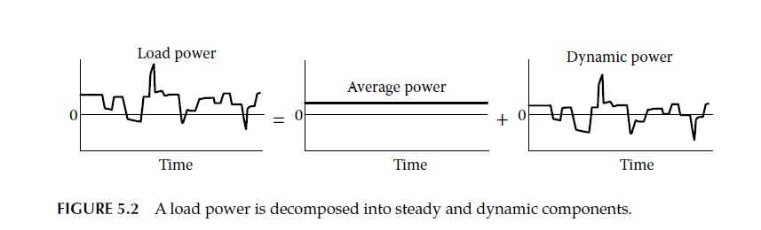

The load power of a vehicle varies randomly in real operation due to frequent acceleration, deceleration, and climbing up and down grades, as shown in Figure 5.2.

Actually, the load power is composed of two components:

one is steady (average) power, which has a constant value, and the other is dynamic power, which has a zero average. In designing the control strategy of a hybrid vehicle, one power train that favors steady-state operation, such as an IC engine and fuel cell, may be used to supply the average power.

On the other hand, another power train, such as an electric motor, may be used to supply the dynamic power. The total energy output from the dynamic power train will be zero in a whole driving cycle.

This implies that the energy source of the dynamic power train does not lose energy capacity

at the end of the driving cycle. It functions only as a power damper.

In a hybrid vehicle, steady power may be provided by an IC engine, a Stirling engine, a fuel cell, and so on. The IC engine or the fuel cell can be much smaller than that in a single power train design because the dynamic power is taken by the dynamic power source, and then can operate steadily in its most efficient region.

The dynamic power may be provided by an electric motor powered by batteries, ultra capacitors, flywheels (mechanical batteries), and their combinations

**1.1 Architectures /Configuration of Hybrid Electric Drive Trains**

The architecture of a hybrid vehicle is loosely defined as the connection between the components that define the energy flow routes and control ports.

Traditionally, HEVs were classified into two basic types: series and parallel. It is interesting to note that, in 2000, some newly introduced HEVs could not be classified into these kinds.

Hence, HEVs are presently classified into four kinds—series hybrid, parallel hybrid, series–parallel hybrid, and complex hybrid—that are functionally shown in Figure 5.3.

Scientifically, the classifications above are not very clear and may cause confusion. Actually, in an HEV, there are two kinds of energy flowing in the drive train: one is mechanical energy and the other is electrical energy. Adding two powers together or splitting one power into two at the power merging point always occurs with the same power type, that is, electrical or mechanical

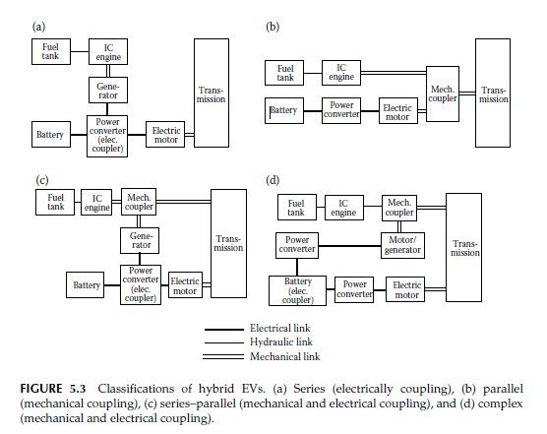

not electrical and mechanical. So perhaps a more accurate definition for HEV architecture may be to take the power coupling or decoupling features such as an electrical coupling drive train, a mechanical coupling drive train, and a mechanical–electrical coupling drive train.

Figure 5.3a functionally shows the architecture that is traditionally called a series hybrid drive train. The key feature of this configuration is that two electrical powers are added together in the power converter, which functions as an electric power coupler to control the power flows from the batteries and generator to the electric motor, or in the reverse direction, from the electric motor to the batteries. The fuel tank, the IC engine, and the generator constitute the primary energy supply and the batteries function as the energy bumper.

Figure 5.3b is the configuration that is traditionally called a parallel hybrid drive train. The key of this configuration is that two mechanical powers are added together in a mechanical coupler. The IC engine is the primary power plant, and the batteries and electric motor drive constitute the energy bumper. The power flows can be controlled only by the power plants—the engine and electric motor.

Figure 5.3c shows the configuration that is traditionally called a series– parallel hybrid drive train. The distinguished feature of this configuration is the employment of two power couplers—mechanical and electrical. Actually, this configuration is the combination of series and parallel structures, possessing the major features of both and more plentiful operation modes than those of the series or parallel structure alone. On the other hand, it is relatively more complicated and may be of higher cost.

Figure 5.3d shows a configuration of the so-called complex hybrid, which has a similar structure to the series–parallel one. The only difference is that the electric coupling function is moved from the power converter to the batteries and one more power converter is added between the motor/generator and the batteries. We will concentrate more on the first three configurations—series, parallel, and series–parallel.

**1.2 Series Hybrid Electric Drive Trains (power flow control and Electrical Coupling)**

A series hybrid drive train is a drive train in which two electrical power sources feed a single electrical power plant (electric motor) that propels the vehicle. The configuration that is most often used is the one shown in Figure 5.4.

The unidirectional energy source is a fuel tank and the unidirectional energy converter (power plant) is an IC engine coupled to an electric generator.

The output of the electric generator is connected to a power DC bus through a controllable electronic converter (rectifier). The bidirectional energy source is a battery pack connected to the power DC bus by means of a controllable, bidirectional power electronic converter (DC/DC converter).

The power bus is also connected to the controller of the electric motor. The traction motor can be controlled as either a motor or a generator, and in forward or reverse motion. This drive train may need a battery charger to charge the batteries by wall plug-in from a power grid. Hybrid drive train

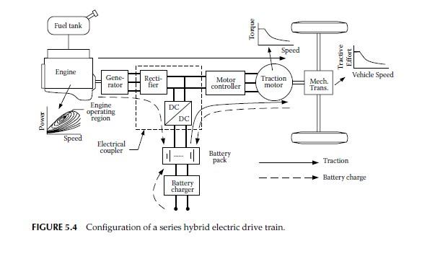

The series hybrid drive train originally came from an EV on which an additional engine–generator is added to extend the operating range that is limited by the poor energy density of the batteries.

The drive train needs a vehicle controller to control the operation and power flows based on the driver’s operating command through accelerator and brake pedals and other feedback information from the components (not shown in Figure 5.4, but for details see Figure 7.1).

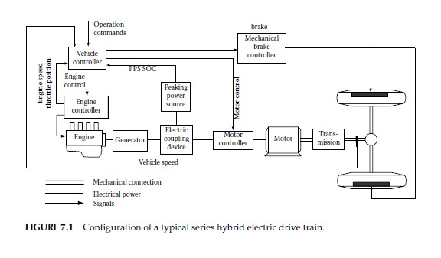

The vehicle controller will control the IC engine through its throttle, electric coupler\ (controllable rectifier and DC/DC converter), and traction motor to produce the demanded propelling torque or regenerative braking torque with one of the following operation modes:

1. **Pure electric traction mode:** The engine is turned off and the vehicle is propelled only from the batteries.

2. **Pure engine traction mode:** The vehicle traction power comes only from the engine–generator, while the batteries neither supply nor accept any power from the drive train. The electric machines serve as an electric transmission from the engine to the driven wheels.

3. **Hybrid traction mode**: The traction powers are drawn from both the engine–generator and the batteries, merging together in the electrical coupler.

4. **Engine traction with battery charging mode:** The engine–generator supplies power to charge the batteries and to propel the vehicle simultaneously. The engine–generator power is split in the electric coupler.

5. **Regenerative braking mode:** The engine–generator is turned off and the traction motor is operated as a generator powered by the vehicle kinetic or potential energy. The power generated is charged to the batteries and reused in later propelling.

6. **Battery charging mode:** The traction motor receives no power and the engine–generator is operated only to charge the batteries.

7. **Hybrid battery charging mode:** Both the engine–generator and the traction motor operate as generators in braking to charge the batteries.

**Series hybrid drive trains offer several advantages:**

1. There is no mechanical connection between the engine and the driven wheels. Consequently, the engine can be potentially operated at any point on its speed–torque (power) map. This distinguished advantage, with a sophisticated power flow control, provides the engine with opportunities to be operated always within its maximum efficiency region, as shown in Figure 5.4.

The efficiency and emissions of the engine in this narrow region may be further improved by some special design and control technologies, which is much easier than in the whole operating domain. Furthermore, the mechanical decoupling of the engine from the driven wheels allows the use of high-speed engines, where it is difficult to directly propel the wheels through a mechanical link, such as gas turbines or power plants that have slow dynamic responses (e.g., Stirling engine, etc.).

2. Because electric motors have a torque–speed profile that is very close to the ideal for traction, , the drive train may not need multigear transmission, as discussed in Chapter

3. Therefore, the structure of the drive train can be greatly simplified and is of less cost. Furthermore, two motors may be used, each powering a single wheel, and the mechanical differential can be removed. Such an arrangement also has the following advantages of decoupling the speeds of two wheels, a similar function of a mechanical differential, and an additional function of antislip similar to the conventional traction control. Furthermore, four in-the-wheel motors may be used, each one driving a wheel. In such a configuration, the speed and torque of each wheel can be independently controlled. Consequently, the drivability of the vehicle can be significantly enhanced.

This is very important for off-road vehicles which usually operate on difficult terrain, such as ice, snow, and soft ground.

3. The control strategy of the drive train may be simple, compared to other configurations, because of its fully mechanical decoupling between the engine and wheels.

However, series hybrid electric drive trains have some disadvantages,

such as the following:

1. The energy from the engine changes its form twice to reach its destination—driven wheels (mechanical to electrical in the generator and electrical to mechanical in the traction motor). The inefficiencies of the generator and traction motor may cause significant losses.

2. The generator adds additional weight and cost.

3. Because the traction motor is the only power plant propelling the vehicle, it must be sized to produce enough power for optimal vehicle performance in terms of acceleration and gradeability.

**2.3 Energy Efficiency analysis:**

**2.3.1 Energy efficiency analysis of HEV:**

When we combine these two things are ICE and EV in a common vehicle or the same vehicle which we are now terming as a hybrid electric vehicle, we have to see that how the losses of the IC engine based powertrain can be minimized. So there is a scope of improving the engine efficiency because it is not alone now, it has a support of EV motor.

Secondly, can we do something for decreasing the loss due to idling operation?

The energy efficiency improvement is possible in a IC engine based powertrain by incorporating a feature which is known as start stop feature. So the engine is no longer needed to keep idling, and it can be stopped whenever supposed to. So this feature enables 6% saving in energy.

In a hybrid electric vehicle, there is also a possibility to store the regenerative braking energy. So this can add another 6% to the energy savings and we can say that if we have these two features, roughly we are saving 12% of the energy

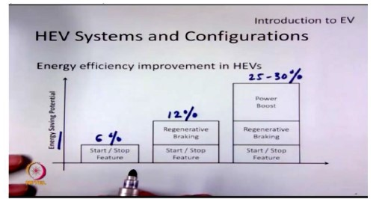

Figure 3.11: Energy efficiency analysis of HEV

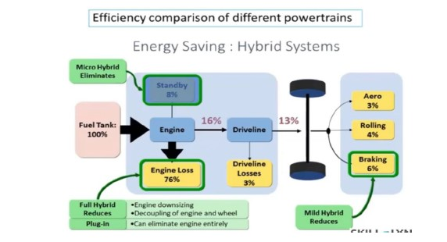

Figure 3.12: Energy efficiency analysis of HEV at Urban driving Conditions

As we have said earlier, the IC engine has a major loss component as heat energy. This is due to the inefficient operation of IC engine. So this can be improved by operating the electric motor such that the IC engine can now operate at its best efficiency. So there is also a possibility to increase another 15 to 20% and it’s possible to get energy saving in the range of 25 to 30%. So we can say that incorporating EV powertrain with a IC engine based powertrain improves the energy spent in the vehicle by around 30%. So as the data shows this kind of energy saving is even better for a urban driving compared to a highway driving.